|  |
| --- |
| Øvelsesrapport: TVA |
| Sebastian Beck  PJG511 |
| 4/12-2019 |

Index

Introduction 3

Method 5

Materials 5

Test procedure 5

Results 6

Longer display times increases accuracy 6

C and K correlates, and age correlates with alpha 6

Sex is not important 7

Selectivity isn’t perfect 8

Conclusion 8

References 8

# Introduction

According to Theory of Visual attention (TVA), conscious recognition of a visual object corresponds to encoding one or more of the object’s properties into a visual shot-term memory storage (Habekost, 2015). The storage has individual variations, but typically has the capacity to hold 3-4 objects. TVA assumes that the visual system automatically processes all objects in our visual field independently and in parallel (Habekost, 2015). Not all objects are processed at an equal speed. Through top-down processes each object is assigned an *attentional weight,* which either stimulate or inhibit the processing speed for that object. Since the capacity is limited, the encoding can be explained as a race, where the objects that are weighted the highest are the fastest, and therefore makes it into the short-term memory storage.

TVA is mathematically model, and is able to measure the following parameters (Habekost, 2015):

* $K$: Capacity of the shot-term memory storage
* $α$: Ratio between target and distractor objects reported. A measure for efficiency of the top-down processes
* $W_{index}$: Measure of spatial bias, left vs right.
* $C$: Total processing speed of the visual system
* $t_{0}$: Lower threshold for visual perception

Figure 1 shows an example of the parameters for one participant.

Figure 1: Example showing t0, C and K for a specific participant (FP19203)

These variables are useful when investigating things like; neglect, neurodegenerative diseases, simultanagnosia etc. (Habekost, 2015).

In our experiment, the following hypothesises were investigated:

1. Accuracy increases with display time
2. There is a correlation between K and C parameters
3. TVA-parameters are correlated with age
4. TVA-parameters are unaffected by sex
5. Distractors inhibits accuracy
6. Attentional weights are not biased to one side

# Method

This experiment included *N* = 207 participants, all psychology students at UCPH.

## Materials

* E-Prime® experiment file containing TVA experiment
* PC

## Test procedure

Prior to starting the experiment, it was verified that the testing monitor had a 60hz refresh rate. Present during the experiment was only the participant (P). The test starts by presenting the instructions. Each P is from the beginning assigned a target colour at random, which can be either red or blue. The target colour isn’t changed throughout the experiment. The test starts by a fixation cross in the target colour appearing for 1000ms. This is replaced by either 2 or 6 letters presented in a circular manner. The letters are displayed in either 16, 33, 50, 100, 150 or 200ms and coloured either red or blue at random. The letters are masked (by a random colour pattern in red and blue) for 500ms, hereafter the screen is blank. P now has to write all letters of the target colour that can be remembered and end by pressing the space key. This starts the next trail. The letters can be presented as all target colour (whole report) or in a 2:4, 3:3 or 4:2 ratio of target and distractors (partial report). The experiment consists of 11 blocks (2 practice) with 27 trails in each. After each block P is presented with an accuracy indication. P has to aim for 80-90% accuracy. If the accuracy is lower than this, more care must be taken in only reporting only letters that are clearly remembered. If accuracy is higher, P must push harder and report letters that they might have seen. It is important that P isn’t guessing. Breaks can be taken after each trail.

# Results

## Longer display times increases accuracy

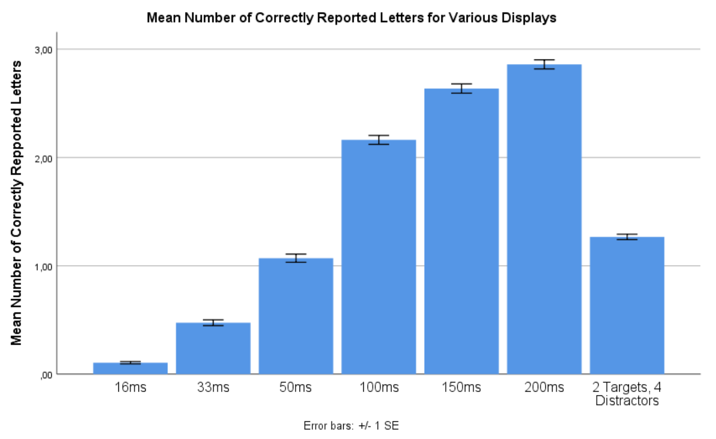

Figure 2: Mean number of correctly reported letters for all displays

Figure 2 suggests that a longer display time, leads to more correctly reported letters. To test this a repeated measures ANOVA was conducted. It showed a significant main effect of display time on number of correctly identified letters, *F*(2.00, 411.36) = 3018.09, *p* < .001, $η_{p}^{2}$ = .94 (Huyhn-Feldt corrected). The main effect of display time on correctly reported letters supports our hypothesis and confirms what figure 2 suggests, that longer display times increases the number of correct responses.

## C and K correlates, and age correlates with alpha

It could be assumed that a higher processing speed (C) would lead to more objects making it into the shot-term memory storage and thereby increasing the capacity (K). Furthermore, previous studies has shown age to correlate with most other TVA parameters (Habekost, 2015). To test both, a two-tailed Pearson’s correlations was conducted. This showed a significant positive correlation between parameters *K* and *C*, *r*(205) = .47, *p* < .001. Age was positively correlated with parameter alpha, *r*(205) = .18, *p* = .01. However, age did not correlate with any of the other TVA parameters, *r*s ≤ .13, dfs = 205, *p*s ≥ .07. This shows some overlap between high processing speed and capacity, as illustrated in figure 3. The correlation between age and alpha, means that the selectivity decreases with age.

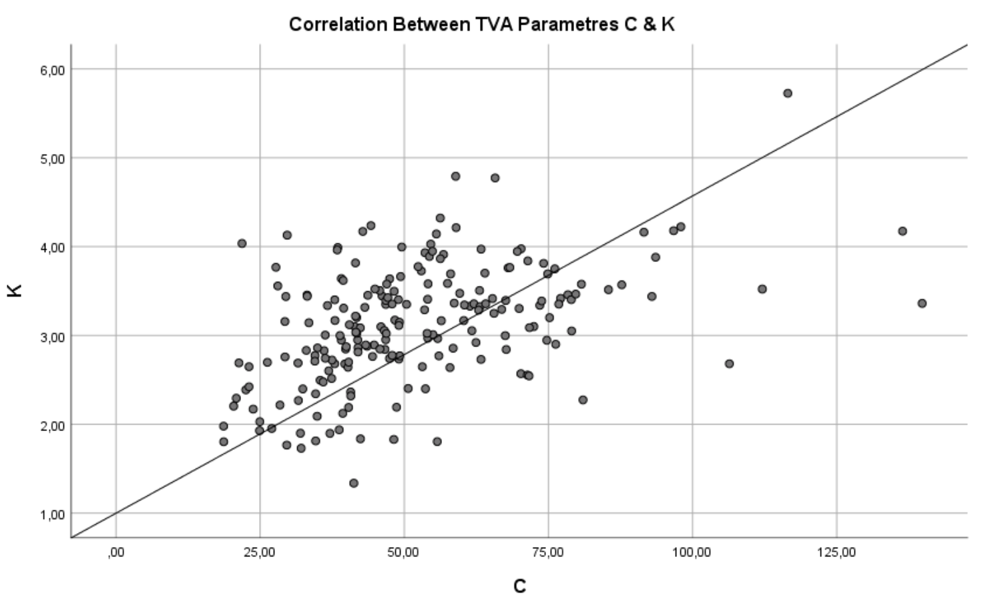

Figure 3: Scatterplot showing correlation between C and K.

## Sex is not important

We used independent samples *t-*tests to test for sex differences, the results are summarized in table 1.

|  |  |  |  |  |  |  |  |  |  |
| --- | --- | --- | --- | --- | --- | --- | --- | --- | --- |
| Table 1 *Mean* *TVA estimates and error rates distributed across sex with relevant t-tests* | | | | | | | | | |
|  | Female (*N* = 169) | |  | Male (*N* = 37) | |  | *t*-tests | | |
|  | *M* | *SD* |  | *M* | *SD* |  | *t*(204) | *p* | *d* |
| *t*0 | 18.55 | (9.20) |  | 16.49 | (8.26) |  | 1.25 | .21 | 0.24 |
| *C* | 51.47 | (19.62) |  | 52.61 | (22.21) |  | -0.31 | .76 | -0.05 |
| *K* | 3.10 | (0.65) |  | 3.18 | (0.68) |  | -0.71 | .48 | -0.13 |
| *alpha* | 0.40 | (0.31) |  | 0.35 | (0.36) |  | 0.89 | .38 | 0.15 |
| *windex* | 0.54 | (0.10) |  | 0.50 | (0.10) |  | 2.23 | .03 | 0.41 |
| *Error rate* | 0.15 | (0.07) |  | 0.16 | (0.07) |  | -0.51 | .61 | -0 |
| *Note*. Units: *t*0 (ms), *C* (letters/second), K (letters), *α* runs from perfect selectivity at 0.0 to no selectivity at 1.0, *w*index (< 0.5 = right side weighting, > 0.5 = left side weighting). | | | | | | | | | |

As shown in table 1, there is only one significant difference between the sexes: $W_{index}$. Men on average have no spatial bias, whereas women on average leans slightly to the left. The big difference in sample size should be considered in this instance, two equal samples might show different results.

To test if $W_{index}$ for the whole sample is perfect, a one-sample *t*-test (two-tailed, alpha = .05) was conducted. This showed a significant difference of Windex from 0.50, *t*(206) = 5.33, *p* < .001, *d* = 0.37. This means that the sample overall is biased towards the left, which again might be due to the sample composition.

## Selectivity isn’t perfect

Under the assumption of perfect selection, and a capacity (K) of more than 2, we expect to see no errors in the 2:4 condition. To test this, a one-sample *t-*test (two-tailed, alpha = .05) on the mean number of correctly reported letters under this condition, was conducted. It showed a significant difference between Mean-2T4D and 2, *t*(206) = -29,47, *p* < .001, *d* = -2.05. This shows selection isn’t perfect, even when the number of targets is well within our capacity limit.

# Conclusion

This experiment has shown that accuracy generally does increase with display time, but that it can be inhibited by distractors. Furthermore, it has shown a correlation between C and K and that alpha increases with age. Finally, it has shown only one significant difference between the sexes, $W_{index}$, where women are biased to the left and men isn’t. But overall, attentional weights are on average biased towards the left.

# References

Habekost, T. (2015). Clinical TVA-based studies: a general review. *Frontiers in Psychology*, *6:290*, 1–18.